**Starting Point: Alfred Park (Chandra Shekhar Azad Park)**

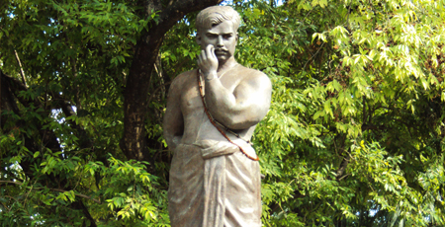

In 1870, Prince Alfred of Saxe-Coburg and Gotha visited Allahabad. A park, 133 acres in area and situated in the heart of the city’s English quarters, Civil Lines, was built to commemorate the event. In 1931, Chandra Shekhar Azad, a revolutionary freedom fighter was engaged in a fierce gun fight with the British in this park. Aged 24, Azad died here on 27 February 1931.

**Allahabad Museum**

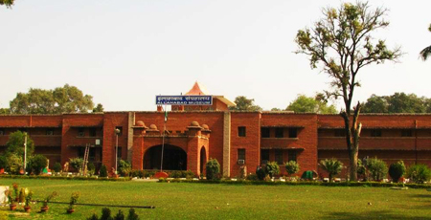

The Allahabad Museum was established in 1863 and is one of the first public museums in India. The museum consists of eighteen galleries that illustrate the development of Indian history. The museum houses sculptures of AK Haldar, pistol of Chandra Shekhar Azad, the brass caskets in which ashes of Mahatma Gandhi were taken to Sangam, salt he made at Dandi, collection of more than six thousand terracotta objects belonging to Kausambi and Mohenjodaro and largest collection of prehistoric rock art.

**Thornhill-Mayne Memorial**

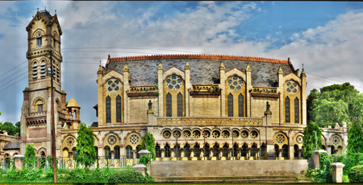

The Allahabad Public Library was founded by the Government of North-Western Frontier Provinces. The present institution, the Rajkeeya (Government) Public Library is housed in the Thornhill-Mayne Memorial building. It was erectedin the memory of C.B. Thornhill and F.O. Mayne, as a testament of their enduring friendship and ascription to the values of scholarship.  
  
The library provides wide range of books, magazines, newspapers, gazettes and other reading materials in Hindi, English, Sanskrit, Urdu, Arabic, Persian, Bangla and French; some notable ones include Majma-ul-Bahrain, the Shahnama of Firdausi and Jyotish-shashtra and Ganesh Puran.

**Victoria Memorial**

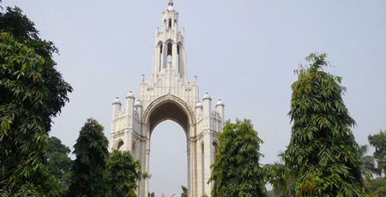

Large canopy made of Italian limestone, dedicated to Queen Victoria. It was opened on 24th of March 1906 by James Digges La Touche. The canopy once sheltered a huge statue of Queen Victoria which was later removed.

**Muir Central College**

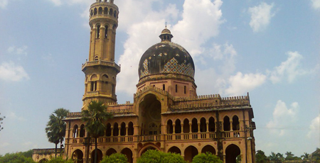

Allahabad University was established on 23rd of September, 1887; it is the fourth oldest university in India. It was established under the aegis of Sir William Muir, the Lt. Governor of the United Provinces, building was designed by Sir William Emerson. The architecture of the college premises reflects influences from Egypt, England and India architectural elements.

**Department of Botany**

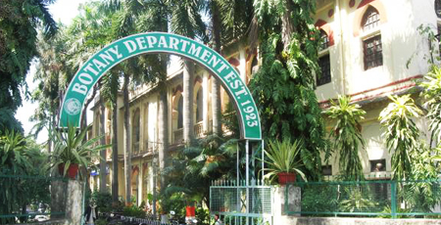

The Department of Botany is housed in a colonial era building, showing classical syncretism with Indo-Islamic style of architecture, a form that is typical for Allahabad. Palm trees line the avenue of the department that was established in 1923. It is one of the oldest botany departments in the country.

**Department of Ancient History**

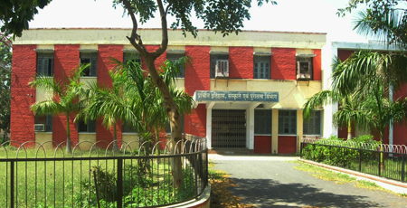

This department has contributed immensely to the study of the Indian prehistory, religion, philosophy, archaeology and anthropology. It was established under the aegis of Prof. G.R. Sharma who has undertaken extensive excavation projects each of archaeological significance. The Department’s work has thrown light on the history of the Ganges valley. The G.R. Sharma Memorial Museum houses antiquities discovered by the Department.

**Central Library**

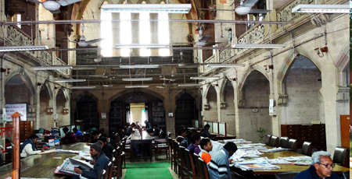

The central library was designed in a confluence of Scottish, Baronial, Awadhi, Mughal and British architectural styles by architect Sir Swinton Jacob. The present structure was built in 1973. In front of the library stands a statue of Suryakant Tripathi Nirala, one of the renowned personalities of Hindi Literature.

**Senate Hall**

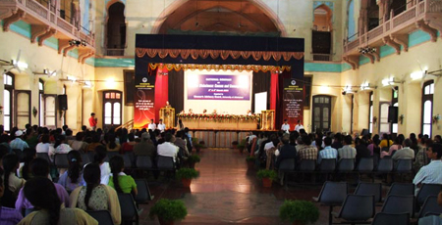

This lofty structure was constructed by Sir Swinton Jacob in 1910-1915. The Senate Hall is decked with chhatries or canopies; the upper storey has balconies or jharokhas which are lined with deep crimson; and the walls are penetrated with typical Allahabadi arches.

**K.P.U.C**

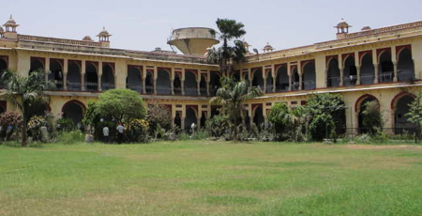

The college was established in 1951and is maintained by the Kayastha Pathashala Trust. Allahabad University has eleven constituent and fourteen hostel colleges.

**Belvedere Printing Works**

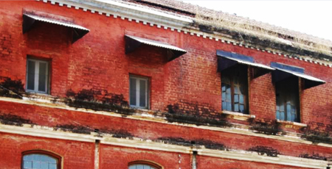

The Belvedere Printing Works was established by Babu Baleshwar Prasad in 1876; at that time it was the only printing press in Allahabad other than the Indian Press. The press printed a renowned newspaper, the Pioneer newspaper (one of the oldest newspapers in India). Rudyard Kipling worked as an Assistant editor of the Pioneer and lived in Belvedere house from 1888-89.

**Jawahar Bal Bhawan**

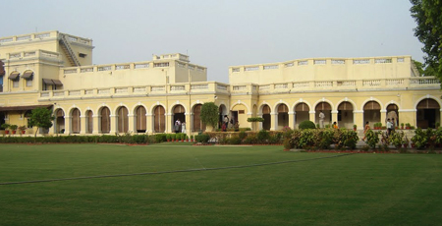

The Bal Bhawan operates from the Swaraj Bhawan complex. It was established by Pt. Jawaharlal Nehru, who felt that the Bal Bhawan is a movement that can harness the capabilities of nation’s students. The Bal Bhawam movement today continues to help children become future creative thinkers, compassionate and responsible citizens who contribute to society.

**Swaraj Bhawan**

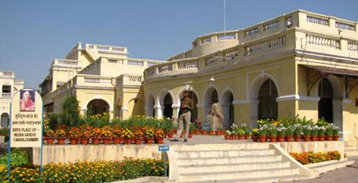

Swaraj Bhawan in the Anand Bhawan complex was a palatial mansion owned by the prominent politician Motilal Nehru. It served as the ancestral home of the Nehru family, Prime Minister, Indira Gandhi was born here. In the 1920s, Motilal Nehru donated the house to the Indian National Congress, and it served as the launch pad of several key movements that defined the history of the Independence movement; it was then called Swaraj Bhawan, the house for self-rule.

**Anand Bhawan**

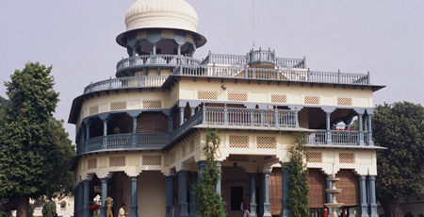

The Annad Bhawan is a historic house museum in Allahabad, which belongs to the Nehru family. It was constructed by Motilal Nehru in the 1930s to serve as the residence of the Nehru family when the original mansion Swaraj Bhawan was transformed into the local headquarters of the Indian National Congress. The Bhawan houses the Jawahar Planetarium.

**Allahabad Planetarium**

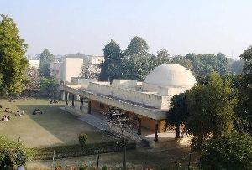

The historical and picturesque city of Allahabad is situated at the confluence and meeting point the rivers Saraswati, Yamuna and Ganges, popularly known to be the Triveni Sangam. The city of allahabad was previously known as Prayag. The city is well known for a famous historical event. The event was that at this city Brahma offered his first sacrifice after creating the world. Allahabad is famous for and is proud of its rich cultural heritage and its religious importance.